**Deploy nodejs application on EKS cluster**

1) Login on docker

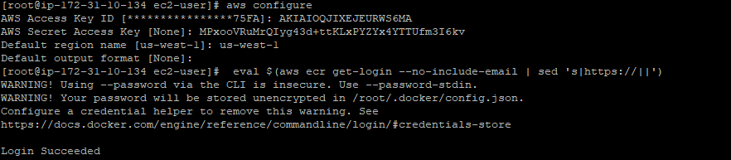

2) Push first app docker image to registry

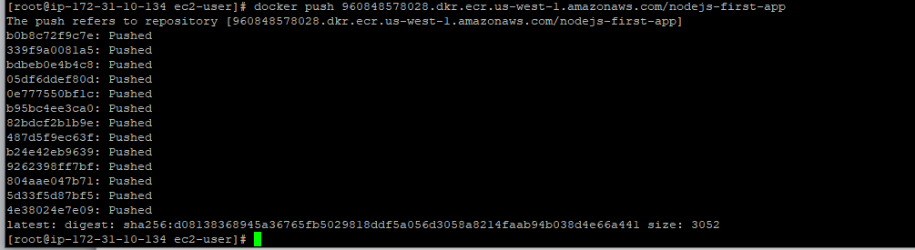

3) Push second app docker image to registry

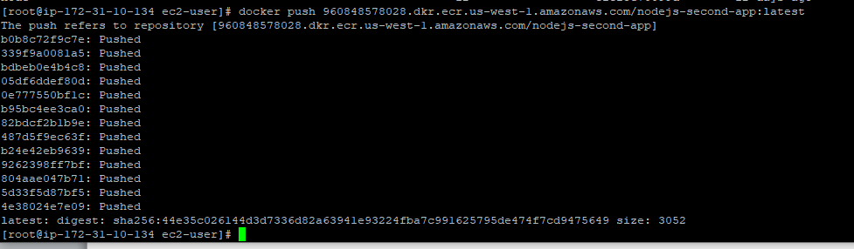

4) Image pushed ECR

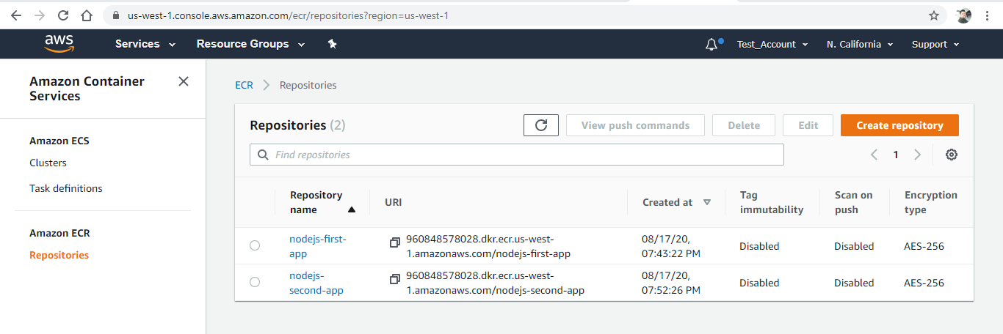

**EKS Cluster setup**

Step 1: Creating an EKS Role

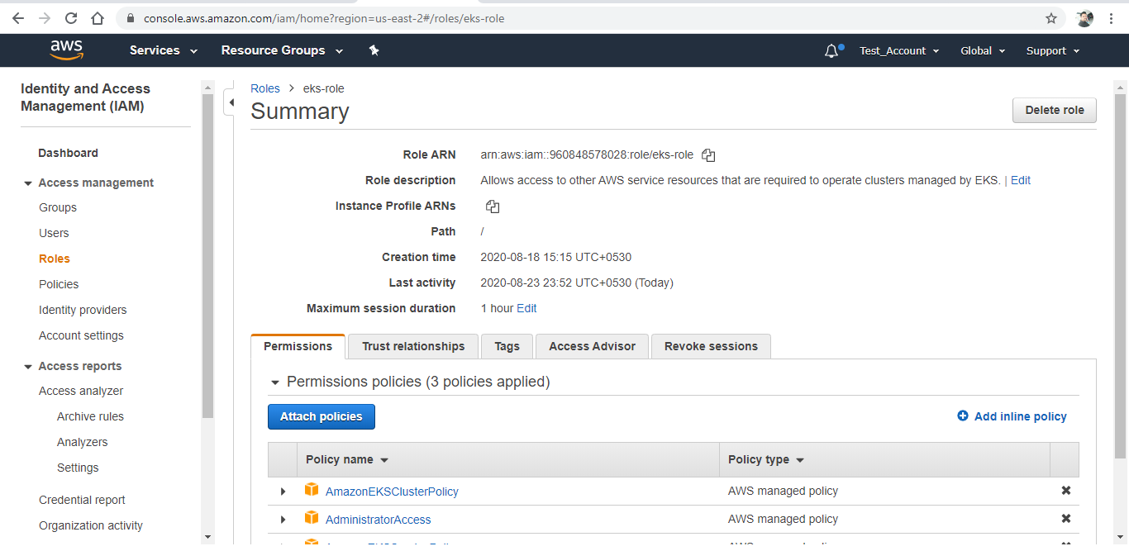

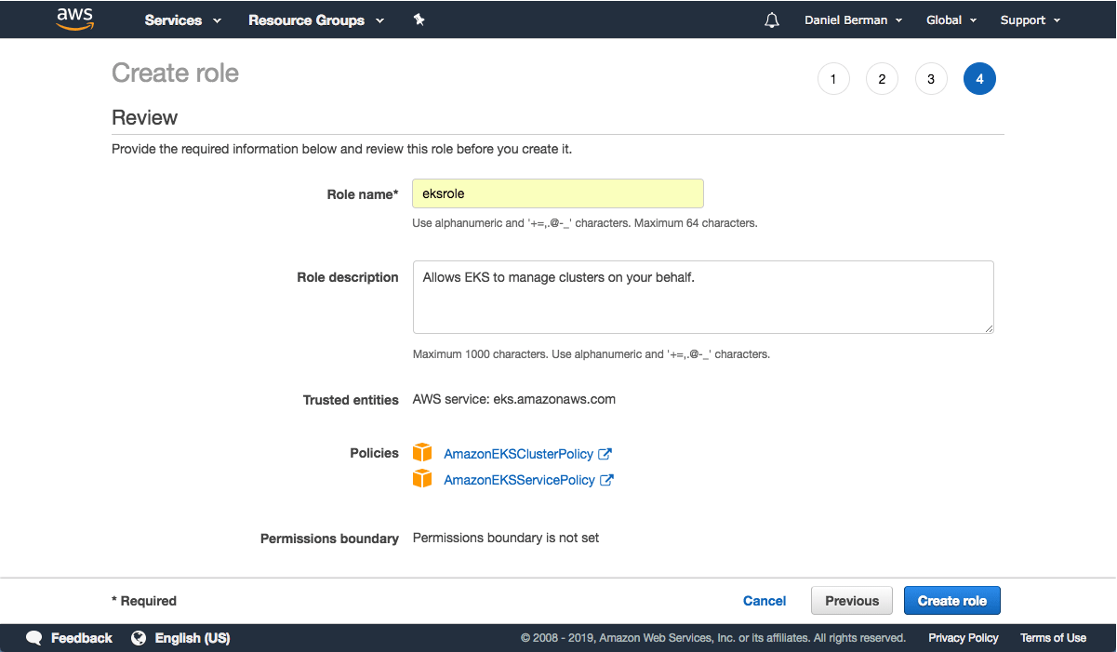



Enter a name for the role (e.g. *eksrole*) and hit the **Create role** button at the bottom of the page to create the IAM role.

The IAM role is created.

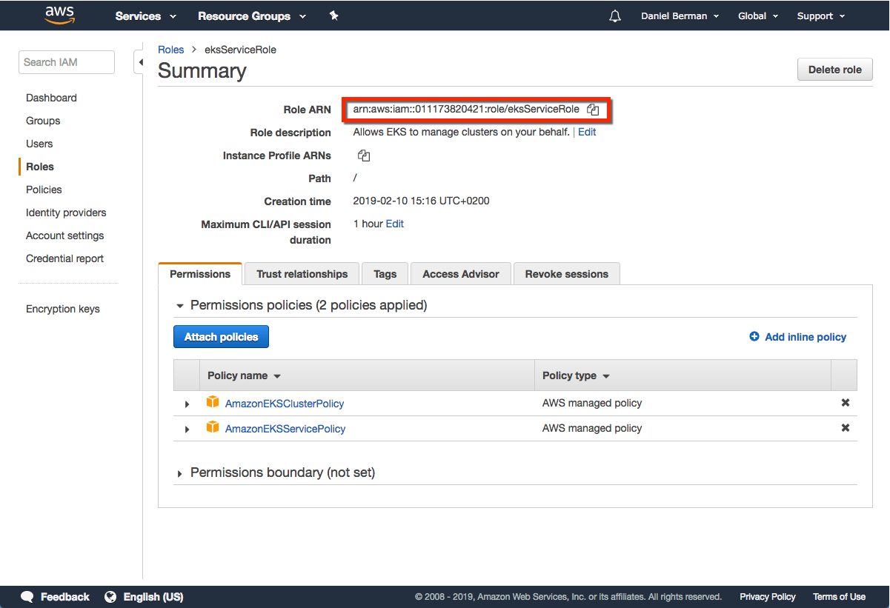

Be sure to note the Role ARN. You will need it when creating the Kubernetes cluster in the steps below.

**Step 2: Creating a VPC for EKS**

Next, we’re going to create a separate VPC for our EKS cluster. To do this, we’re going to use a CloudFormation template that contains all the necessary EKS-specific ingredients for setting up the VPC.

Open up [CloudFormation](https://console.aws.amazon.com/cloudformation" \t "_blank), and click the **Create new stack** button.

On the **Select template** page, enter the URL of the CloudFormation YAML in the relevant section:

https://amazon-eks.s3-us-west-2.amazonaws.com/cloudformation/2019-01- 09/amazon-eks-vpc-sample.yaml

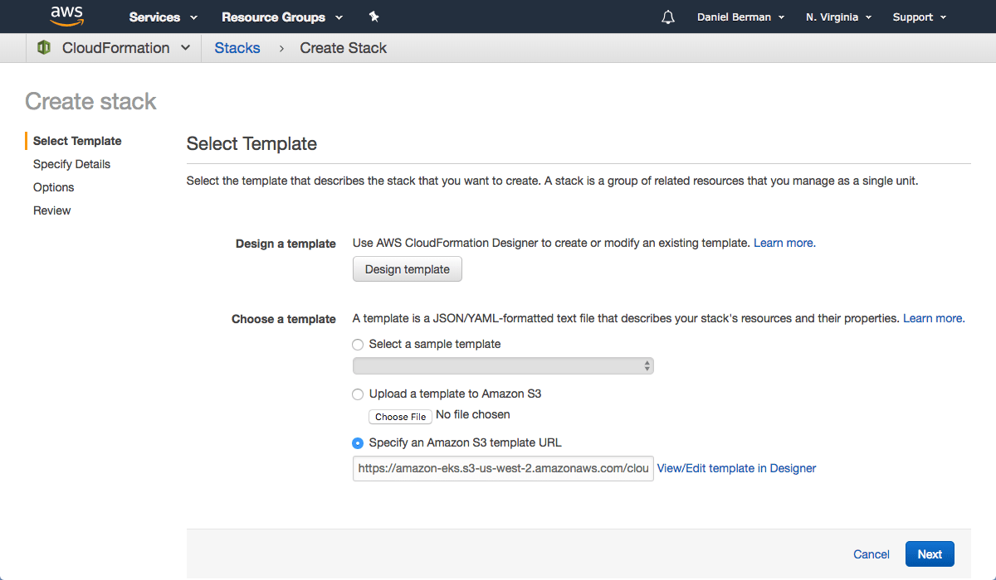

Click **Next**.

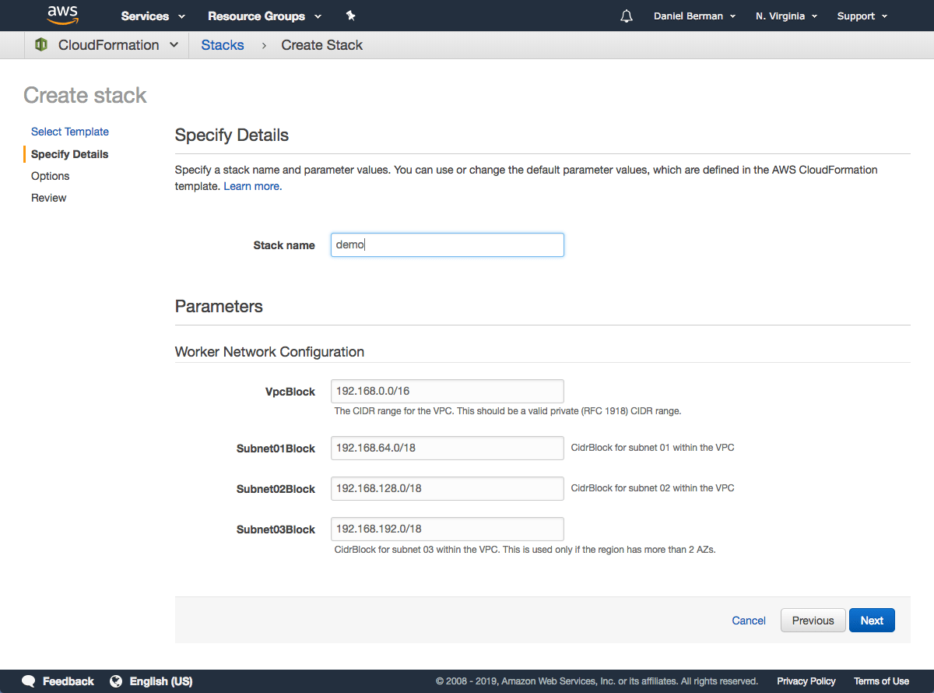

Give the VPC a name, leave the default network configurations as-is, and click **Next**.

On the Options page, you can leave the default options untouched and then click **Next**.

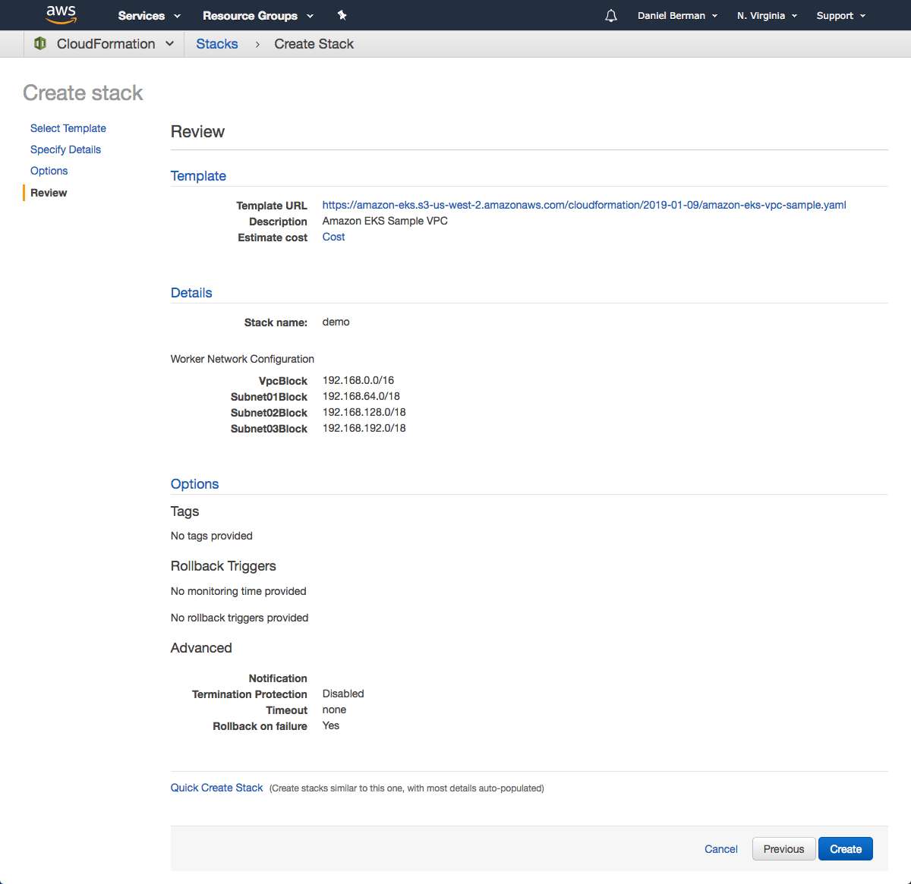

On the Review page, simply hit the **Create** button to create the VPC.

CloudFormation will begin to create the VPC. Once done, be sure to note the various values created — SecurityGroups, VpcId and SubnetIds. You will need these in subsequent steps. You can see these under the Outputs tab of the CloudFormation stack:

## demo

## **Step 3: Creating the EKS Cluster**

As mentioned above, we will use the AWS CLI to create the Kubernetes cluster. To do this, use the following command:

aws eks create-cluster \

--region us-east-2 \

--name eks-cluster \

--role-arn arn:aws:iam::960848578028:role/eks-role \

--resources-vpc-config subnetIds=subnet-038d5d5c7321eee4a,subnet-04ca3f1b4af49e506,subnet-00e209942d2be567e,securityGroupIds=sg-0d689bdedcccfe660

Cluster created

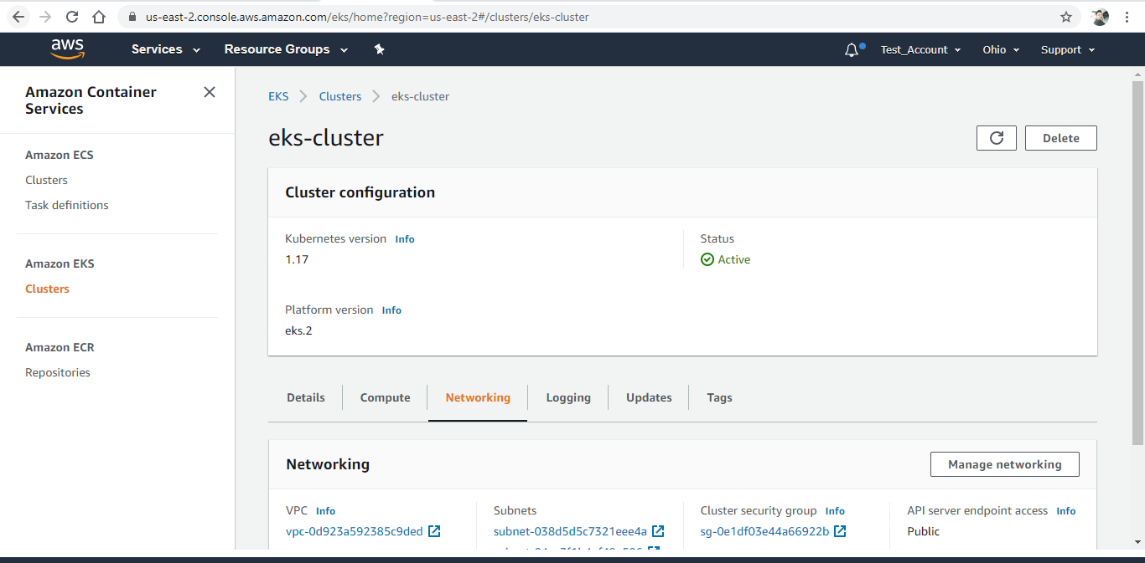

4) Nodes joined to EKS cluster

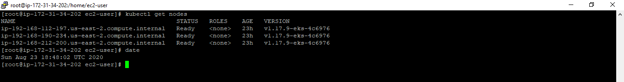

5) Nodejs application deployed on EKS cluster

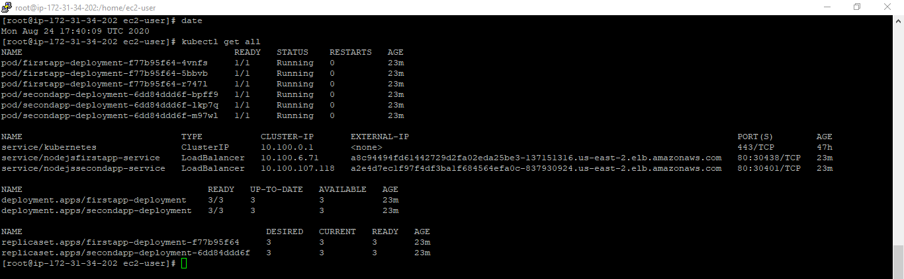

6) Nodejs application is accessible on ELB port 80

